1. Open the first screen of your app by right clicking on it, then selecting “GUI Builder” :

Level of difficulty:   
Estimated time: 5 mn

[**www.codapps.io**](http://www.codapps.io)by Clement Levallois **@codapps_io** [**www.coursera.org/learn/codapps**](http://www.coursera.org/learn/codapps)



**Module 2: How to add text, pics, links etc. to your app**

*How to add text to your app*

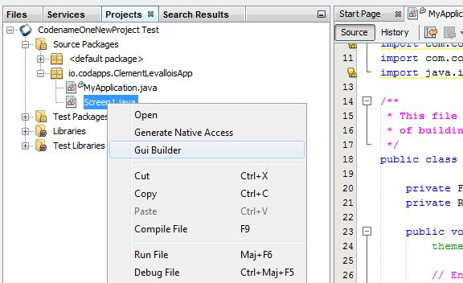

**1. Right click on the name of your screen**

**2. Select « GUI Builder »**

1. This opens a new window, which should look like this:

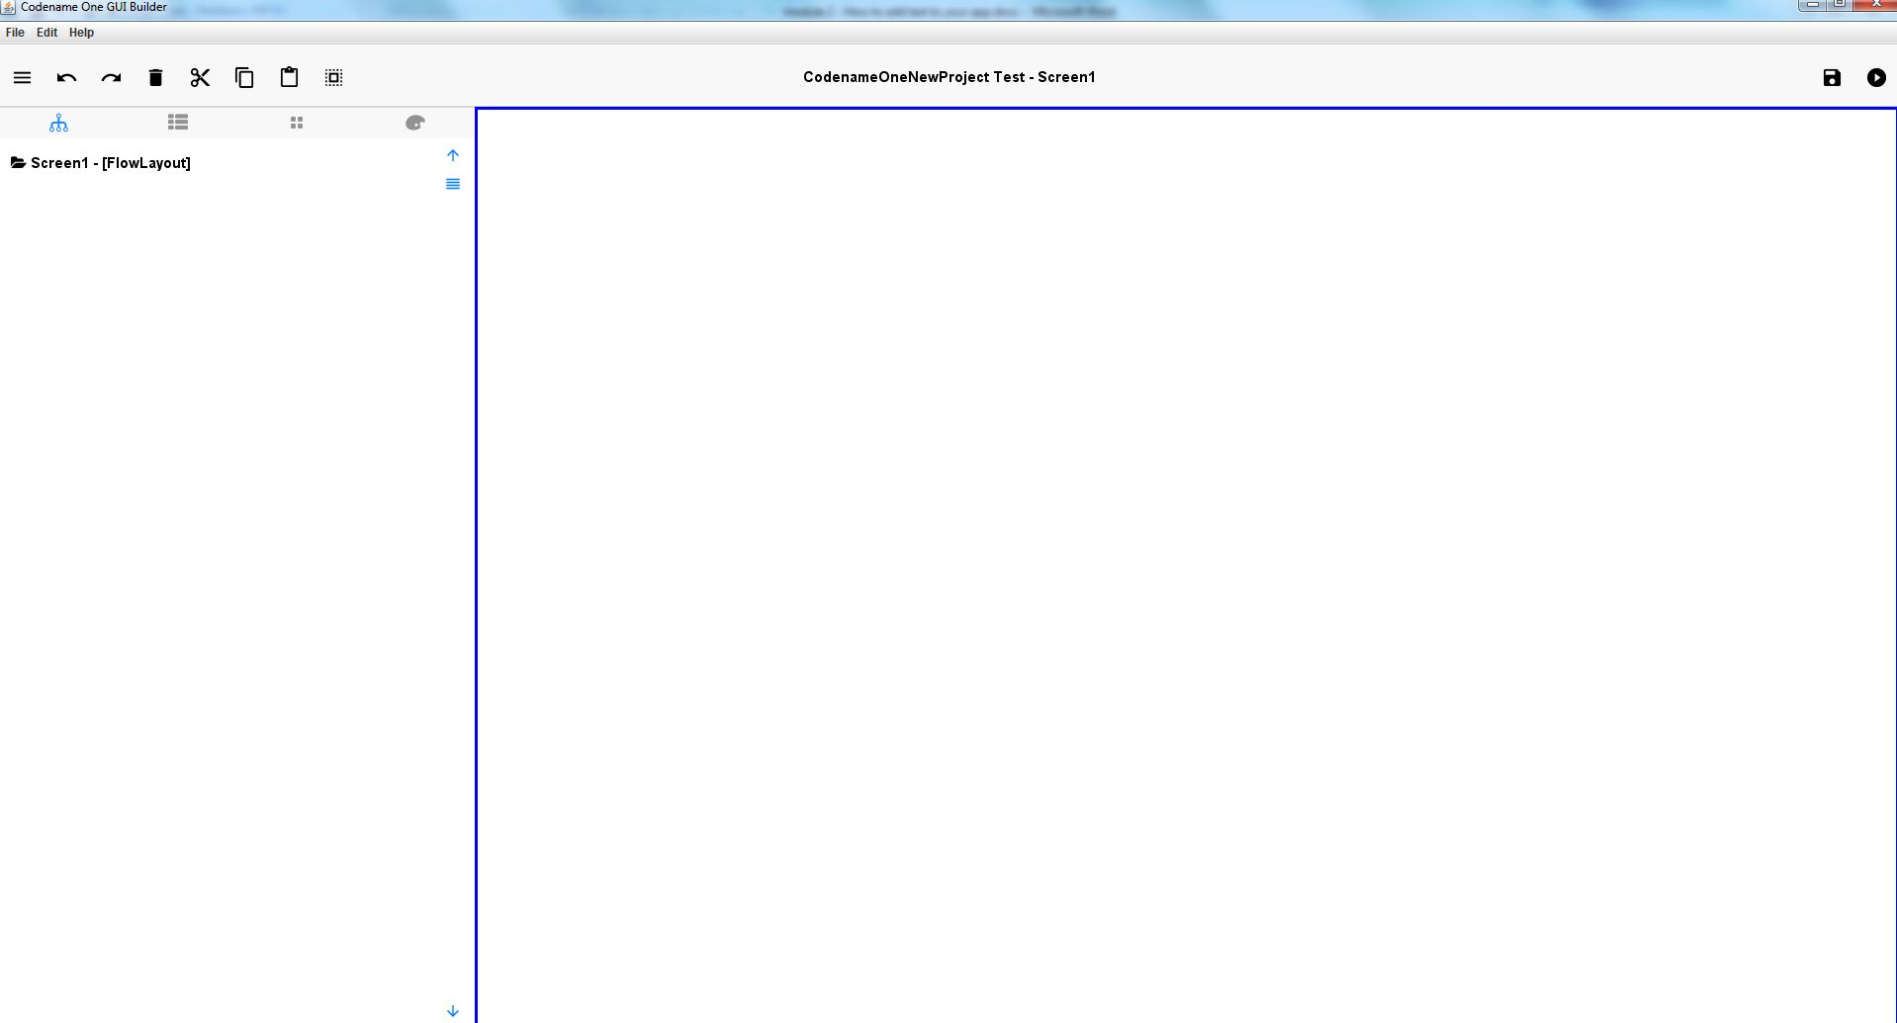

1. To add some text :

Level of difficulty:   
Estimated time: 5 mn

**Module 2: How to add text, pics, links etc. to your app**

*How to add text to your app*

[**www.codapps.io**](http://www.codapps.io)by Clement Levallois **@codapps_io** [**www.coursera.org/learn/codapps**](http://www.coursera.org/learn/codapps)



1. Click on the “Palette” icon ( ). This shows everything you can use to put on a screen of your mobile apps.
2. Drag and drop the .Label icon ( ) to the empty screen on the right.
3. You now see the label on your screen.

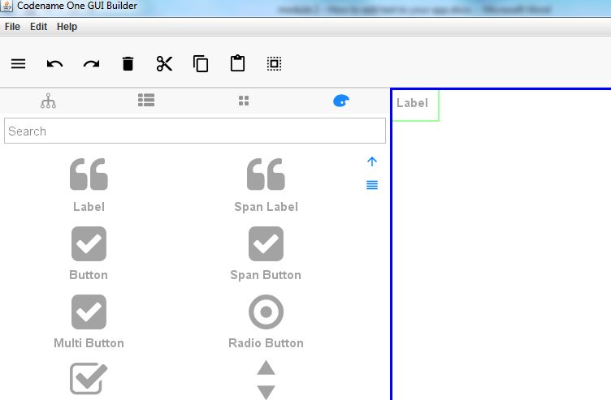

**c) after the drag and drop, you should see the label here, on your screen!**

**b) drag and drop the Label to the screen**

**a) Click on this icon**

1. Changing the text of the Label, to put the one you want!

Level of difficulty:   
Estimated time: 5 mn

1. Select your Label on the screen by clicking on it. **You know it is properly selected when it has green borders**:

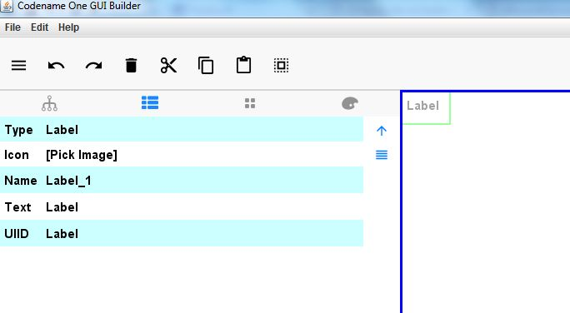

Click here

1. Or, an alternative way to select your Label:

Click on the Tree ico n ( ) , then click on the Label:

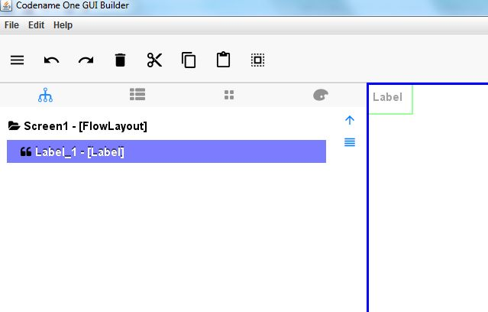

a. Click here

b. Click here



[**www.codapps.io**](http://www.codapps.io)by Clement Levallois **@codapps_io** [**www.coursera.org/learn/codapps**](http://www.coursera.org/learn/codapps)



**Module 2: How to add text, pics, links etc. to your app**

*How to add text to your app*

c. Click on the “Property Sheet” of the Label, then change its text:

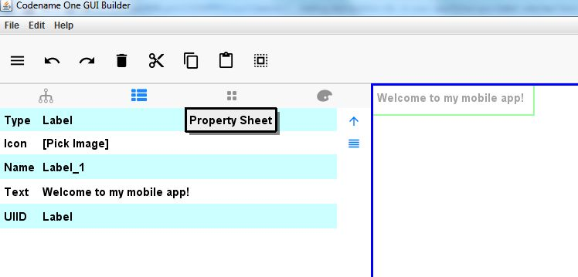

a. Click here

c. Your text can be see here!

b. Change the text here. Click “Enter” to see the changes

1. In the palette menu, I see Labels but also “Span Labels”. What is the difference between the two ?

**Module 2: How to add text, pics, links etc. to your app**

*How to add text to your app*

Level of difficulty:   
Estimated time: 5 mn

[**www.codapps.io**](http://www.codapps.io)by Clement Levallois **@codapps_io** [**www.coursera.org/learn/codapps**](http://www.coursera.org/learn/codapps)



* The text of a Label gets cut if it is too long for the screen
* 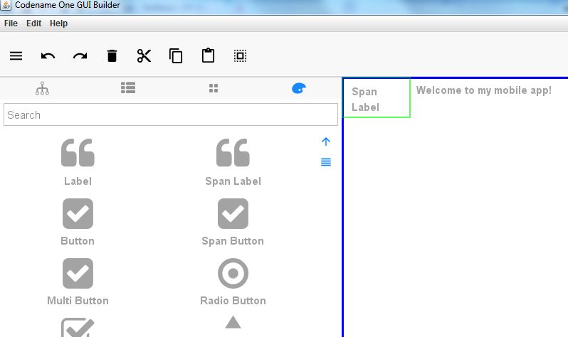The text of a SpanLabel breaks nicely into several lines when it is too long for the screen.